Integrating the Healthcare Enterprise



IHE PCC

Technical Framework Supplement

Patient Plan of Care
(PPOC)

Supplement For Trial Implementation

Date: August 1, 2009
Author: Keith W. Boone
Email: keith.boone@ge.com

This is a supplement to the IHE PCC Technical Framework V4.0

Details about IHE may be found at: www.ihe.net

Details about the IHE Patient Care Coordination may be found at: http://www.ihe.net/Domains/index.cfm

Details about the structure of IHE Technical Frameworks and Supplements may be found at: http://www.ihe.net/About/process.cfm and http://www.ihe.net/profiles/index.cfm

The current version of the IHE Patient Care Coordination Technical Framework may be found at:. http://www.ihe.net/Technical_Framework/index.cfm

These “boxed” instructions are for the author to indicate to the Volume Editor how to integrate the relevant section(s) into the overall Technical Framework
Replace Section X.X by the following:
TABLE OF CONTENTS
Introduction 3
Profile Abstract 3
Open Issues and Questions 3
Closed Issues 3
Glossary 4
2.5 Dependencies among Integration Profiles 4
2.7 History of Annual Changes 4
X Patient Plan of Care Content Profile 5
Use Case 6
X.1 Actors and Transactions 7
X.3 Grouping 9
X.4 Content Modules 10
X.5 Patient Plan of Care Process Flow 11
X.6 Patient Plan of Care Security Considerations 12

Introduction
This supplement adds the Patient Plan of Care (PPOC) Profile to Volume I of the IHE PCC Technical Framework, and the Patient Plan of Care Document Content Module and related modules to Volume II.

Profile Abstract
The Patient Plan of Care profile (PPOC) extends the description of the content structures for the plan of care in the current technical framework and is based on the data elements from the Nursing Process currently in common use. The PPOC includes the following additional components in a clinical document:
- Assessment
- Diagnosis
- Outcomes Identification
- Planning
- Implementation
- Evaluation
This profile defines the implementation of HL7 CDA documents to represent these data elements along with the XDS, XDR and XDM bindings. The PPOC is a content profile that is intended to eventually sit within a larger folder structure that contains documents related to interdisciplinary continuity of care for the patient. This profile also defines mechanisms to group them into a single logical folder.
The PPOC profile provides a mechanism for electronic exchange of data related to creating and managing individualized patient care between and among HIT systems. The PPOC demonstrates the exchange of this information based on concepts for diagnoses, interventions, and outcomes in a standardized framework using the American Nurses Association (ANA) nursing process to evolve its information model.

Open Issues and Questions

Closed Issues

Volume 1 – Integration Profiles

Glossary
Standards of Practice: The American Nurses Association defines Standards of Practice as follows:
The six Standards of Practice describe a competent level of nursing care as demonstrated by the critical thinking model known as the nursing process. The nursing process includes the components of assessment, diagnosis, outcomes identification, planning, implementation and evaluation. The nursing process encompasses all significant actions taken by registered nurses, and forms the foundation of the nurse’s decision making.
Standard 1: Assessment:
The registered nurse collects comprehensive data pertinent to the patient’s health or the situation.
Standard 2: Diagnosis:
The registered nurse analyzes the assessment data to determine the diagnoses or issues.
Standard 3: Outcomes Identification:
The registered nurse identifies expected outcomes for a plan individualized to the patient and situation.
Standard 4: Planning:
The registered nurse develops a plan then prescribes strategies and alternatives to attain expected outcomes.
Standard 5:Implementation:
The Registered nurse implements the identified plan
Standard 6: Evaluation:
The registered nurse evaluates the progress toward attainment of outcomes.

2.7 History of Annual Changes
Add the following bullet to the end of the bullet list in Section 2.7
In the 2009-2010 cycle of the Patient Care Coordination Initiative, the following content profile was added as a supplement to the technical framework.
- Added the PPOC Profile that extends the description of the content structures for the plan of care in the current technical framework and is based on the data elements from the Nursing Process currently in common use.
Add Section X

X Patient Plan of Care Content Profile
The fundamental building block of any high-performance health system is reliable information about the effectiveness of care. Nurses act as the 24 hour coordinator of care for the entire inpatient care process. The Patient Plan of Care is an individualized, mutually agreed upon plan. This PPOC Profile describes the contribution of Registered Nurses to the plan. The plan includes problem issues (nursing diagnoses), expected healthcare outcomes, implementable interventions, and evaluation of progress toward outcomes based on follow up assessment. It is a framework to document critical thinking necessary for excellent evidenced based outcomes.
Each healthcare discipline provides a plan agreed upon with the patient/advocate, based on license and the discipline’s scope of practice. Future work is expected to add contributions to PPOC from each healthcare profession .
Standardized coded documentation by nursing is one of the largest data gaps in care delivery. Furthermore, nursing documentation of non- numeric human responses to actual or potential health threats are infrequently transferred electronically at the current time.
This PPOC content profile scope contains five of the six components of the nursing process to document human response. The assessment information, as described in the use case, is added to support a depiction of change in health status leading to patient admission, discharge and transfer to another level of care. Assessment documentation profiles, will be proposed in future years and as such will not be in scope for the current work.

The PPOC Profile provides a mechanism for capture and electronic exchange of data related to creating and managing individualized patient care between and among HIT systems. This profile enables the exchange of this information based on concepts for diagnoses, interventions, and outcomes in a standardized framework using the American Nurses Association (ANA) nursing process to evolve its information model. It is for example informed by models of care used in the Clinical Care Classification (CCC) System, and can convey the concepts found in that and other controlled vocabularies.
These models extend the description of the content structures for the plan of care in the current technical framework. The PPOC focuses on the following six components in a clinical document:
- Assessment
- Nursing Diagnosis
- Outcomes Identification
- Planning
- Implementation (Interventions)
- Evaluation
The components of the process are shown in Figure X-1 below. When a patient arrives for care (e.g., upon admission or transfer of care) they undergo an initial assessment. The care planning process includes diagnoses, outcomes identification (goals), and the planning of care with the patient or their advocate. The nursing process continues with the nurse implementing actions to provide care for the patient based on the plan. Evaluation measures the current patient progress against the expected outcomes through subsequent assessments. Evaluations are used to adjust the nursing plan . These components are performed continuously through the care process.

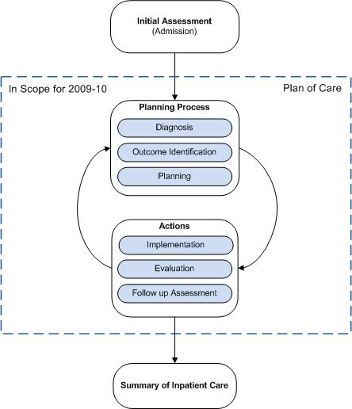

Figure X-1 Nursing Process
This profile defines the implementation of an HL7 CDA document to represent the data elements needed for care planning, along with the IHE profile bindings to support the exchange of the information. The PPOC is a content profile that is intended to eventually sit within a larger folder structure that contains documents related to continuity of care for the patient. This profile also defines mechanisms to group them into a single logical folder.
Regardless of where nurses practice, the PPOC Profile is able to support coded nursing documentation. This allows healthcare organizations to access data on the complexity of patient conditions and the care performed by professional nurses and other allied professionals to improve the quality of care provided and facilitate continuity of care.

Use Case
A 70 year old male is admitted to a hospital unit after presenting to the Emergency Department (ED)with productive cough, acute rib pain, increased work of breathing, decreased lung sounds bilaterally, pulse oximetry saturation of 88%, temperature of 39 degrees Celsius (102.2 degrees Fahrenheit), heart rate of 108, and blood pressure of 156/88. Chest x-ray done in ED showed bilateral lower lobe and right middle lobe infiltrates. Medical diagnosis is Pneumonia.
Upon admission to the unit, the nurse reviews documentation of ED care delivery, clinician orders, labs, xrays, and any other available data. An assessment is completed by the nurse. With assessment and information obtained in ED, the nurse determines issues (nursing diagnosis), expected outcomes, recommended interventions and evaluation criteria. The nurse determines:
Issues (nursing diagnoses)
- Respiratory alteration
- Acute pain
Expected outcomes:
- Maintenance of oxygen saturation at 95% on room air by pulse oximetry when ambulating
- Pain maintained within the patient’s comfort threshold (0-3) on oral medications
Planning:
- Interventions planned, based on research evidence, demonstrated to meet quality outcomes
- Information is reviewed with the patient/advocate for agreement and implemented in the plan of care
Implementation of interventions:
- Elevation of head of bed 30 to 45 degrees
- Humidified oxygen by nasal canula at 2 liters to maintain saturation above 92%
- Splinting of chest with pillow to reduce pain with cough
Evaluation:
- Pulse Oximetry is measured at 95 % when walking in hall
- Pain when coughing is reported by patient to be less than 3 on pain scale with oral medications.
Further assessments occur with any change of condition or at recommended intervals. Evaluation criteria is compared to outcomes assessed and changes in the PPOC are made. The patient is the owner of the plan of care and mutual agreement of change is the norm.

X.1 Actors and Transactions
There are two actors in this profile, the Content Creator and the Content Consumer. Content is generated by a Content Creator and is to be consumed by a Content Consumer. The sharing or transmission of content from one actor to the other is addressed by the appropriate use of IHE profiles described below, and is out of scope of this profile. A Document Source or a Portable Media Creator may embody the Content Creator Actor. A Document Consumer, a Document Recipient or a Portable Media Importer may embody the Content Consumer Actor. The sharing or transmission of content or updates from one actor to the other is addressed by the use of appropriate IHE profiles described by section 3.7 Content Bindings with XDS, XDM and XDR found in the Patient Care Coordination Technical Framework



Figure X.1-2 Patient Plan of Care Actors and Transactions

X.2 Patient Plan of Care Options

Actor | Option | Section
Content Consumer | View Option (See Note 1)  Document Import Option (See Note 1)  Section Import Option (See Note 1)  Discrete Data Import Option (See Note 1) | PCC TF-2: 3.0.1  PCC TF-2: 3.0.2  PCC TF-2: 3.0.3  PCC TF-2: 3.0.4
Content Creator | None
Note 1: The Actor shall support at least one of these options.

X.3 Grouping
This section describes the behaviors expected of the Content Creator and Content Consumer actors of this profile when grouped with actors of other IHE profiles.

X.3.1 Content Bindings with XDS, XDM and XDR
It is expected that the exchanges of this content will occur in an environment where healthcare organizations have a coordinated infrastructure that serves the information sharing needs of this community of care. Several mechanisms are supported by IHE profiles:
- A registry/repository-based infrastructure is defined by the IHE Cross Enterprise Document Sharing (XDS) and other IHE Integration Profiles such as patient identification (PIX & PDQ) and notification of availability of documents (NAV).
- A media-based infrastructure is defined by the IHE Cross Enterprise Document Media Interchange (XDM) profile.
- A reliable messaging-based infrastructure is defined by the IHE Cross Enterprise Document Reliable Interchange (XDR) profile.
- All of these infrastructures support Security and privacy through the use of the Consistent Time (CT) and Audit Trail and Node Authentication (ATNA) profiles.
For more details on these profiles, see the IHE IT Infrastructure Technical Framework. Content profiles may impose additional requirements on the transactions used when grouped with actors from other IHE Profiles.

X.3.2 Cross Enterprise Document Sharing, Media Interchange and Reliable Messages
Actors from the ITI XDS, XDM and XDR profiles most often embody the Content Creator and Content Consumer sharing function of this profile. A Content Creator or Content Consumer may be grouped with appropriate actors from the XDS, XDM or XDR profiles, and the metadata sent in the document sharing or interchange messages has specific relationships to the content of the clinical document described in the content profile.

X.3.3 Audit Trail and Node Authentication (ATNA)
When the Content Creator or Content Consumer actor of this profile is grouped with the Secure Node or Secure Application actor of the ATNA profile, the content creator actor shall generate appropriate audit record events for each of the following trigger events:

Trigger Event | Description
Actor-start-stop | Start up and shut-down of the content creator or content consumer actor.
Patient-Record-Event | Creation, access, modification or deletion of the content described within this profile.
Node-Authentication-Failure | Secure node authentication failure is detected.

Figure X.3: Minimum Trigger Event Set
The above list is a minimum set that must be demonstrated by all actors of this profile when grouped with the secure node or secure application actor. Additional audit records shall also be generated depending upon the actions available the product implementing the secure node or secure application actor.

X.3.4 Notification of Document Availability (NAV)
A Document Source should provide the capability to issue a Send Notification Transaction per the ITI Notification of Document Availability (NAV) Integration Profile in order to notify one or more Document Consumer(s) of the availability of one or more documents for retrieval. One of the Acknowledgement Request options may be used to request from a Document Consumer that an acknowledgement should be returned when it has received and processed the notification.
A Document Consumer should provide the capability to receive a Receive Notification Transaction per the NAV Integration Profile in order to be notified by Document Sources of the availability of one or more documents for retrieval. The Send Acknowledgement option may be used to issue a Send Acknowledgement to a Document Source that the notification was received and processed.

X.3.5 Document Digital Signature (DSG)
When a Content Creator Actor needs to digitally sign a document in a submission set, it may support the Digital Signature (DSG) Content Profile as a Document Source. When a Content Consumer Actor needs to verify a Digital Signature, it may retrieve the digital signature document and may perform the verification against the signed document content.

X.4 Content Modules
Content Modules describe the content of a payload found in an IHE transaction. Content profiles are transaction neutral. They do not have dependencies upon the transaction in which they appear. This integration profile defines one content module, the PPOC, defined in section PCC TF-2:6.1.1.Y.
While the PPOC focuses on the nursing process, it is a summary document containing the necessary information for the interdisciplinary care planning process.
This content module incorporates other content modules already present in this Technical Framework. The names of these content modules do not always use the terminology found in nursing (e.g., Review of Systems). However, the data elements found in these sections are identical in content regardless of the scope of practice for the clinical discipline providing that information.
The purpose of this section is to identify the type of information found in the PPOC. The clinician generating this information is separately identified within the content module. Those two pieces together provide sufficient information to interpret the content.

X.5 Patient Plan of Care Process Flow
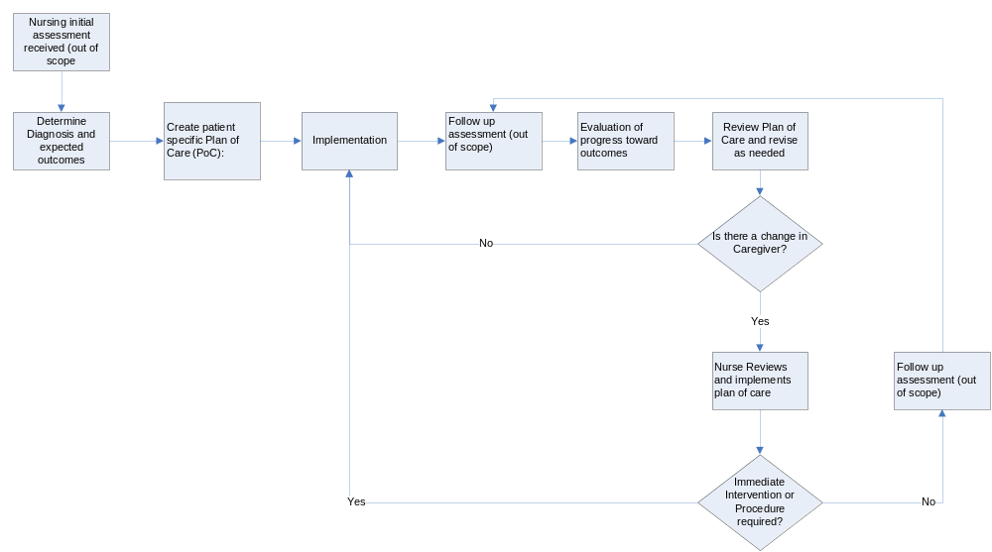

Figure X.3.1: Patient Plan of Care Process Flow
This process flow diagram shows the movement of the PPOC over the course of care for a patient as an inpatient on a Nursing Unit. This diagram specifically excludes other infrastructure interactions for simplicity and readability. These infrastructure interactions may be found elsewhere in this and other IHE frameworks.
The data from a PPOC are exchanged electronically between and among health technology information systems for each of the steps of the Nursing Process. The PPOC may also be exchanged with consultants and other interested providers who may then update the PPOC, and return the updated record to the sender, primary care provider, patient, and/or other interested providers.

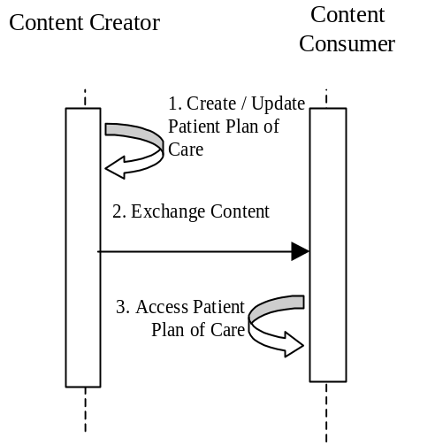
Figure X.3-2. Basic Process Flow in the Patient Plan of Care Profile
The following steps show the use of the PPOC Profile during the nursing process.
- A patient admitted as an inpatient to a hospital for a clinical diagnosis or a surgical procedure requires nursing care. A nurse reviews the clinically relevant data and with the patient develops an individualized plan articulating specific individualized care for that patient based on the Nursing Process. This model includes medical and nursing orders within the electronic health record (EHR) system. The nurse documents the nursing related content for a specific PPOC using coded nursing terminology.
- The PPOC is stored within an HIT system.
- During the inpatient stay, the nurses continually evalauate their actions and review the PPOC frequently to ensure progress and quality care are maintained. The Patient Plan of Care is revised as needed (e.g., in the case of new information or a change in patient condition).
The following describes these steps used in the context of a transfer of care.
- When a patient is transferred to another facility the PPOC is reviewed and updated as needed to promote continuity of care.
- The updated PPOC is exchanged with the destination facility.
- The PPOC is reviewed at the destination facility and is updated as needed.

X.6 Patient Plan of Care Security Considerations
<Description of the Profile specific security considerations. This should include the outcomes of a risk assessment. This likely will include profile groupings, and residual risks that need to be assigned to the product design, system administration, or policy.>

Reference:
American Nurses Association. (2004). Nursing: Scope & Standards of Practice. Silver Spring, MD. ANA.
O'Kane, M., Corrigan, J., Foote, S.M., Tunis, S.R., Isham, G.J., Nichols, L.M., Fisher, E.S., Ebeler, J.C., Block, J.A., Bradley, B.E., Cassel, C.K., Ness, D.L., Tooker, J. Crossroads in Quality. Health Affairs (Millwood). 2008 May-Jun. 27(3). 749-58.
Saba, V. (2007). Clinical Care Classification (CCC) System Manual: A Guide to Nursing Documentation. Springer. NY, NY.

Volume 2 – Transactions and Content

Add Section 6.1.1.Y to the end of Section 6.1.1

6.1.1 CDA Document Content Modules

6.1.1.Y Care Plan Specification 1.3.6.1.4.1.19376.1.5.3.1.1.20.1.1
The nursing evaluation and management note contains the information relevant to the six components of the nursing process described by the American Nursing Association Standards of Nursing Practice (ANA 2004). These include:
- Assessment
The assessment includes the collection of data pertinent to the patient’s health. This assessment may include review of systems and/or physical examination details and vital signs, functional status or potential risks to the patient. Additional sections may be added to include relevant family / social history, or other key knowledge necessary to the implementation of the nursing plan.
- Nursing Diagnosis
The problem list section includes any diagnoses based on assessment data and information received from other providers.
- Expected Outcomes
Identification of individualized expected outcomes for the patient (the goals)
- Planning
Planning is the stage in the process to prescribe treatments and interventions to be implemented to reach the expected outcomes under the plan. Planning includes patient/advocate expectations.
- Implementation
Implementation of the plan includes the actions and interventions performed along with care provided to the patient.
- Evaluation
Evaluation of the effectiveness of the plan is identified at the time of assessment The nurse documents patient response toward PPOC goal attainment.
In addition to these sections, the PPOC may also include other information relevant to the planning process, such as:
- Discharge Planning
The PPOC includes notation of anticipated discharge needs and progress towards meeting those needs. This includes patient and family teaching, prescriptions, durable medical equipment, social/medical services etc.
- Orders
The PPOC includes a section referencing clinician orders and actions that are to be implemented, including any orders for treatment (e.g., medications, therapy, et cetera), monitoring (testing, monitoring, et cetera) or education.
- Allergies
The PPOC documents the presence or absence of patient allergies.
- History of Past Illness
The PPOC includes History of Past Illness relevant to care planning
- Surgical History
The PPOC includes any relevant prior surgical history.
- Advance Directives
The PPOC includes information about any relevant advance directives or note their absence.
- Immunizations
The PPOC includes information about the patient’s immunization status (e.g., recent flu shot).
- Family and Social History
The PPOC includes information about relevant family and social history pertinent to the individualized care the patient requires.
The document content module specifies which IHE templates to use for each of the above components. However, the sections described above are not necessarily an exhaustive list of all necessary sections. Additional information may be required based on the context of the care being provided.. The IHE PCC Technical framework contains a library of section templates that may be used within this document content module.

6.1.1.Y.1 LOINC Code
The LOINC code for this document is 34746-8 Nursing Evaluation and Management Note

6.1.1.Y.2 Standards
CDAR2 | HL7 CDA Release 2.0
CCD | ASTM/HL7 Continuity of Care Document
ANA 2004 | ANA Nursing Scope and Standard of Practice

6.1.1.Y.3 Data Element Index
Data Element | LOINC | ANA 2004
Assessment | X-ASSESS ASSESSMENTS | Assessment
Physical Examination | 29545-1 PHYSICAL EXAMINATION | Assessment
Review of Systems | 10187-3 REVIEW OF SYSTEMS | Assessment
Functional Status Assessment | 47420-5 FUNCTIONAL STATUS ASSESSMENT | Assessment
Family History | 10157-6 HISTORY OF FAMILY MEMBER DISEASES | Assessment
Social History | 29762-2 SOCIAL HISTORY | Assessment
History of Past Illness | 11348-0 HISTORY OF PAST ILLNESS | Assessment
Surgical History | 47519-4 HISTORY OF PROCEDURES | Assessment
Active Problems | 11450-4 PROBLEM LIST | Diagnosis
Allergies | 48765-2 Allergies, adverse reactions, alerts | Diagnosis
Goals | X-OUTCOME Outcome Identification | Outcome Identification
Care Plan | 18776-5 Plan of Treatment | Planning
Provider Orders | 46209-3 PROVIDER ORDERS | Planning
Advance Directives | 42348-3 ADVANCE DIRECTIVES | Planning
Procedures and Interventions | 29544-3 PROCEDURES | Implementation
Medications Administered | 18610-6 MEDICATION ADMINISTERED | Implementation
Fluids Administered | 8975-5 INTRAVASCULAR FLUID INTAKE | Implementation
Progress | 27574-3 Progress Note and Attainment of Goals | Evaluation

6.1.1.Y.4 Specification
This section references content modules using Template ID as the key identifier. Defintions of the modules are found in either:
- IHE Patient Care Coordination Volume 2: Final Text
- IHE PCC Content Modules 2009-2010 Supplement (For Public Comment)

Data Element Name | Opt | Template ID
Assessments  This section should include all assessments performed. | R | 1.3.6.1.4.1.19376.1.5.3.1.1.13.2.4
Physical Examination  The physical examination section should be present when a physical examination is performed during the assessment of the patient. | C | 1.3.6.1.4.1.19376.1.5.3.1.1.9.15
Review of Systems  The review of systems section should be present when a review of systems is performed during the assessment of the patient. | C | 1.3.6.1.4.1.19376.1.5.3.1.3.18
Functional Status Assessment  This section should be present when any assessments of functional status are performed on the patient. | C | 1.3.6.1.4.1.19376.1.5.3.1.1.12.2.1
Family History  This section should be present when there is relevant family history | O | 1.3.6.1.4.1.19376.1.5.3.1.3.14
Social History  This section should be present when there is relevant social history | O | 1.3.6.1.4.1.19376.1.5.3.1.3.16
Active Problems  The problem list section includes any nursing and physician diagnoses that are relevant to or being addressed by the PPOC. | R | 1.3.6.1.4.1.19376.1.5.3.1.3.6
Allergies and Other Adverse Reactions Section  This section should be present and record the presense or absense of any allergies. | R | 1.3.6.1.4.1.19376.1.5.3.1.3.13
Treatment Plan  The treatment plan section contains a description of the planned care and goals. | R | 1.3.6.1.4.1.19376.1.5.3.1.3.31
Provider Orders  References any orders that are to be implemented, including those for treatment (e.g., medications, therapy or therapeutic encounters, et cetera), monitoring (testing, monitoring, et cetera), or education. | R | 1.3.6.1.4.1.19376.1.5.3.1.1.20.2.1
Advance Directives Section  This section should be present and record the presence or absense of any advance directives. | R | 1.3.6.1.4.1.19376.1.5.3.1.3.34
Procedures and Interventions  This section should be present when procedures and interventions have been performed. | C | 1.3.6.1.4.1.19376.1.5.3.1.1.13.2.11
Medications Administered  This section should be present when medications have been administered. | C | 1.3.6.1.4.1.19376.1.5.3.1.3.21
Fluids Administered  This section should be present when fluids have been administered. | C | 1.3.6.1.4.1.19376.1.5.3.1.1.13.2.6
History of Past Illness Section  This section should be present when there is relevant history of past illness. | C | 1.3.6.1.4.1.19376.1.5.3.1.3.8
Coded List of Surgeries Section  This section should be present when there is relevant surgical history. | C | 1.3.6.1.4.1.19376.1.5.3.1.3.12
Immunizations Section  This section should be present to record relevant immunization status. | C | 1.3.6.1.4.1.19376.1.5.3.1.3.23
R = Required; R2 = Required if data present; O = Optional; C = Conditional

6.1.1.Y.5 Conformance
CDA Release 2.0 documents that conform to the requirements of this content module shall indicate their conformance by the inclusion of the appropriate <templateId> elements in the header of the document. This is shown in the sample document below.
Sample Care Plan Document
<ClinicalDocument xmlns='urn:hl7-org:v3'>
<typeId extension="POCD_HD000040" root="2.16.840.1.113883.1.3"/>
<templateId root='1.3.6.1.4.1.19376.1.5.3.1.1.20.1.1'/>
<id root=' ' extension=' '/>
<code code='34746-8' displayName='Nursing Evaluation and Management Note'
codeSystem='2.16.840.1.113883.6.1' codeSystemName='LOINC'/>
<title>Care Plan</title>
<effectiveTime value='20090506012005'/>
<confidentialityCode code='N' displayName='Normal'
codeSystem='2.16.840.1.113883.5.25' codeSystemName='Confidentiality' />
<languageCode code='en-US'/>
:
<component><structuredBody>
<component>
<section>
<templateId root='1.3.6.1.4.1.19376.1.5.3.1.1.13.2.4'/>
<!-- Required Assessments Section content -->
</section>
</component>
<component>
<section>
<templateId root='1.3.6.1.4.1.19376.1.5.3.1.1.9.15'/>
<!-- Conditional Physical Examination Section content -->
</section>
</component>
<component>
<section>
<templateId root='1.3.6.1.4.1.19376.1.5.3.1.3.18'/>
<!-- Conditional Review of Systems Section content -->
</section>
</component>
<component>
<section>
<templateId root='1.3.6.1.4.1.19376.1.5.3.1.1.12.2.1'/>
<!-- Conditional Functional Status Assessment Section content -->
</section>
</component>
<component>
<section>
<templateId root='1.3.6.1.4.1.19376.1.5.3.1.3.14'/>
<!-- Optional Family History Section content -->
</section>
</component>
<component>
<section>
<templateId root='1.3.6.1.4.1.19376.1.5.3.1.3.16'/>
<!-- Optional Social History Section content -->
</section>
</component>
<component>
<section>
<templateId root='1.3.6.1.4.1.19376.1.5.3.1.3.6'/>
<!-- Required Active Problems Section content -->
</section>
</component>
<component>
<section>
<templateId root='1.3.6.1.4.1.19376.1.5.3.1.3.13'/>
<!-- Required Allergies and Other Adverse Reactions Section Section content -->
</section>
</component>
<component>
<section>
<templateId root='1.3.6.1.4.1.19376.1.5.3.1.3.31'/>
<!-- Required Care Plan Section content -->
</section>
</component>
<component>
<section>
<templateId root='1.3.6.1.4.1.19376.1.5.3.1.1.20.2.1'/>
<!-- Required Provider Orders Section content -->
</section>
</component>
<component>
<section>
<templateId root='1.3.6.1.4.1.19376.1.5.3.1.3.34'/>
<!-- Required Advance Directives Section content -->
</section>
</component>
<component>
<section>
<templateId root='1.3.6.1.4.1.19376.1.5.3.1.1.13.2.11'/>
<!-- Conditional Procedures and Interventions Section content -->
</section>
</component>
<component>
<section>
<templateId root='1.3.6.1.4.1.19376.1.5.3.1.3.21'/>
<!-- Conditional Medications Administered Section content -->
</section>
</component>
<component>
<section>
<templateId root='1.3.6.1.4.1.19376.1.5.3.1.1.13.2.6'/>
<!-- Conditional Fluids Administered Section content -->
</section>
</component>
<component>
<section>
<templateId root='1.3.6.1.4.1.19376.1.5.3.1.3.8'/>
<!-- Conditional History of Past Illness Section Section content -->
</section>
</component>
<component>
<section>
<templateId root='1.3.6.1.4.1.19376.1.5.3.1.3.12'/>
<!-- Conditional Coded List of Surgeries Section Section content -->
</section>
</component>
<component>
<section>
<templateId root='1.3.6.1.4.1.19376.1.5.3.1.3.23'/>
<!-- Conditional Immunizations Section Section content -->
</section>
</component>

</structuredBody></component>
</ClinicalDocument>

American Nurses Association (2004). Standards of Clinical Nursing Practice. Washington, DC: ANA
O'Kane M, Corrigan J, Foote SM, Tunis SR, Isham GJ, Nichols LM, Fisher ES, Ebeler JC, Block JA, Bradley BE, Cassel CK, Ness DL, Tooker J. (2008).Health Affairs;27(3):749-58.
Saba, V.K. (2007). Clinical Care Classification (CCC) System Manual: a Guide to Nursing Documentation. New York, NY, Springer Publishing
Clinical documents are not normally modified after being finalized. However, prior to that event one or more parties may author the content in stages. Each subsequent stage should be treated as a modification of the previous stage.
This step does not always involve and exchange between different HIT systems.

